**Question I**

Choose two companies (that you are relatively familiar with) each using two distinctive selling channels (i.e., online versus retail) to sell their products.

The two companies chosen for this question are Dell and Banana Republic (BR).

For each company and for each selling channel identify:

1. How customer segmentation is achieved
   * Dell Online: Customers are segmented in a variety of ways through the online channel to take advantage of price elasticity and increase contribution. For example, group pricing is utilized by offering corporate discounts for online purchases to employees of companies enrolled in the discount program. Also, online couponing is used as a self-selection pricing approach. Product versioning is also used to differentiate products through minor differences as well as broadly differentiated categories of products such as their “for home” computers vs. “for work” computers. Dell also sells laptops through other online retailors such as the Microsoft online store through which they sell “signature edition” version of their laptops specifically configurations to suggest perhaps a better alignment with the Windows OS.
   * Dell Retail: Customers are segmented through offering different versions of their computers through various retailers. For example, Dell may sell “for home” computers at Best Buy, and sell “for work” computers at Office Depot. Further product versioning is utilized to sell specific configurations of their computers at various electronics and office supply retailors.
   * BR Online: Online couponing seems to be the primary strategy of customer segmentation for this clothing retailor. Coupon codes are emailed and advertised online to draw price elastic customers looking for deep discounts. Also, time-based product versioning is used in which an online sale may last for only a limited time frame that’s advertised.
   * BR Retail: One way in which BR applies time-based differentiation is by selling out of season products at their outlet stores and primarily keeping in season products at their regular retail stores. Within the regular retail stores, clearance items are regularly sold as well at discounts. Also, volume discounts tend to be used at the retail channel in which “buy 1, get 1 half off” type of deals seem to be quite regular.
2. How products are designed (or differentiated) for each segment
   * Dell Online: Taking the Microsoft online store segment, the product is designed to have a higher end configuration with the strongest processors, higher memory and storage as well as advertised to have been configured specifically to optimally run the Windows OS. The segment that is being targeted is a fairly price inelastic segment that is looking for the best pc laptop product they can find.
   * Dell Retail: Taking the Office Depot segment, Dell would offer a small business model laptop such as the Latitude line with discounts, targeting small/home business customers who may be more price elastic.
   * BR Online: Taking the online coupon hunting segment, BR is not necessarily designing their products differently but may be trying to find the right buyers for the remaining inventory that tend to have a lower demand (e.g. certain colors, styles and sizes). Conversely, a specific product in a certain size and color may not be available at a retail store for a customer but may be available online. In such situations, although no explicitly targeted, the product being offered online allows for this type of segmentation of a class of price inelastic customers who can’t find the product at their local retail stores.
   * BR Retail: Taking the Outlet segments, the former is clearly offering their out of season and low demand inventory to the perhaps less fashion conscious and hence price elastic customers. Conversely they reserve the in season products for their more price inelastic customers who may be more willing to pay for the latest fashion styles and trends.

1. How price segmentation is implemented. What types of “fences” are used to avoid consumers’ spillovers
   * Dell Online: Product versioning is the key method in which fences are used in the online channel. By allowing customers to customize their desktop and laptop configurations, Dell can effectively keep the different segments separated. They can manage the pricing of the configurations in way that can best aligns to the various price elasticity customer segments they’ve defined. For example, adding extra RAM generally costs substantially more than what it would cost to buy and install the additional memory separately. However, this extra RAM is clearly priced to be directed to the price inelastic customer who is willing to pay a premium for the best possible performance.
   * Dell Retail: By offering their desktops and laptops at different retailors, Dell can maintain fences. For example, Dell may sell a slightly differently configured versions of the same laptop a Best Buy vs Office Depot. This may allow them to perhaps promote the Best Buy version as a slightly superior model vs the Office Depot version. By selling the products at two different retailors aimed at general different customer segments, Dell can maintain a fence between the two customer segments for essentially the same product.
   * BR Online: A typical fence used for fashion is availability. For example, for a fashion conscious, price inelastic customer, they may not know exactly how long or how many products may be available. As such, this may incentivize the customer to make the purchase instead of waiting for a discount to come about, resulting in a natural fence between the price inelastic customer and the price elastic customer who would be willing to wait for a discount. This fence may be stronger in the online channel, because the customer can see the remaining inventory in terms of sizes. So if a customer is looking for a medium and sees that all Larges have been sold out, that may provide the perception that the product may be sold out in the near future.
   * BR Retail: The uncertainty of the duration of the discount may be an effective fence for retail channel. For instance, if a customer sees a limited time 40% discount offer at the store, he/she may feel inclined to ‘take advantage’ of this offer because there’s no guarantee that the same or higher level of discount will be offered in the future. For a fairly price elastic customer looking for a great deal, this may incentivize them to make the purchase and effectively serve as a fence between them and the extremely price elastic customer who may only be interested in 50% discounts for the same products.
2. How pricing strategies differ between the two selling channels
   * Dell: The online strategy clearly is heavily based on product versioning through customization and self-selection through couponing. Whereas, the retail channel strategy is to leverage existing differentiation through electronics retailors and place variations of their products to best target their intended customer segments.
   * BR: The general strategy between online and retail for BR seems quite similar in that both utilize similar discount offers and clearance sections to differentiate between the regular priced in style and in season products and the out of season offerings. However, a point of distinction between the two channels may be the extent and variety of discounts that may be available. Online coupons may be offered in a higher variety compared to the discounts offered at retail.
3. Can you suggest alternative ways to (i) segment demand and (ii) differentiate their products?
   * Dell:
     1. An alternative approach to segment demand for Dell would be to have clear markdowns similar to clothing. Everyone knows new versions and models of their laptops will be coming out. Perhaps clearing up the opacity of the timing of new models and offering a clearer markdown phase of expiring product lineups, may help them further segment demand and draw the extremely price elastic customers to the markdown pricing phase for the best possible deals.
     2. An alternative approach to differentiate their product may be to offer the option to customize the design of the products. This approach would likely be much more feasible through the online channel and would work towards giving customers that added customization feature at and added cost, which would then further segment the most price inelastic customers. Another way in which this customization can be applied is by combining it with a corporate discount offer in which the corporate customers may purchase desktop and laptops that have the company logo on it.
   * BR:
     1. An alternative approach to segment demand for BR may be to offer certain styles of their products at general clothing retailors such as Macy’s. They may choose to offer certain clothing lines that open up their offering to a much larger customer segment. Similarly, they can choose to offer their products through other online retailors such as Zappos that have a great return policy, and in effect attract a whole new customer segment who may be more willing to make an online purchase of BR clothing knowing that returning the product would be a rather painless and seamless effort.
     2. An alternative approach to differentiate their product for BR may be to offer a children’s line for parents seeking to buy a slightly more upscale clothing for their children than what they can find at GAP. This would introduce BR to a new customer segment who are willing to pay a premium for a specific type of children’s clothing that may be as readily available as the typical casual wear sold by GAP.

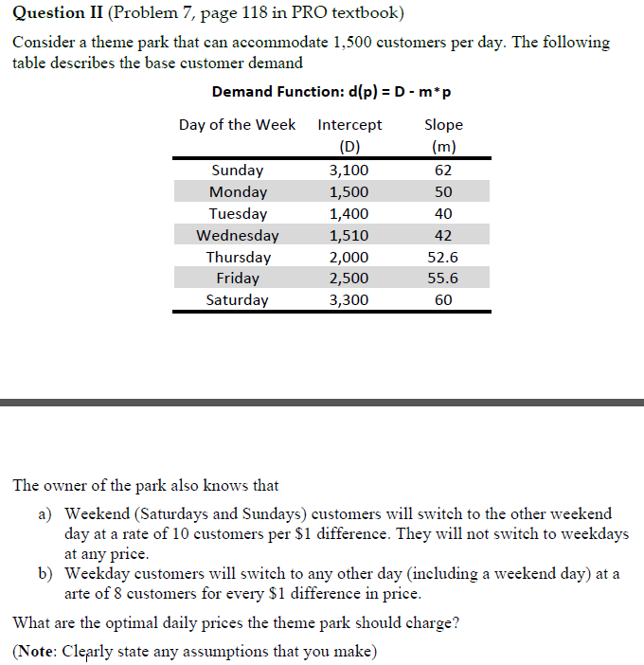

The daily optimal prices are noted in the Excel solver non-linear optimization solution below. See C10:I10 for the daily prices from Sun to Sat respectively. Solved this variable pricing with diversion problem by calculating the daily demand as a function of not just the price for the day but for all the other days of the week.



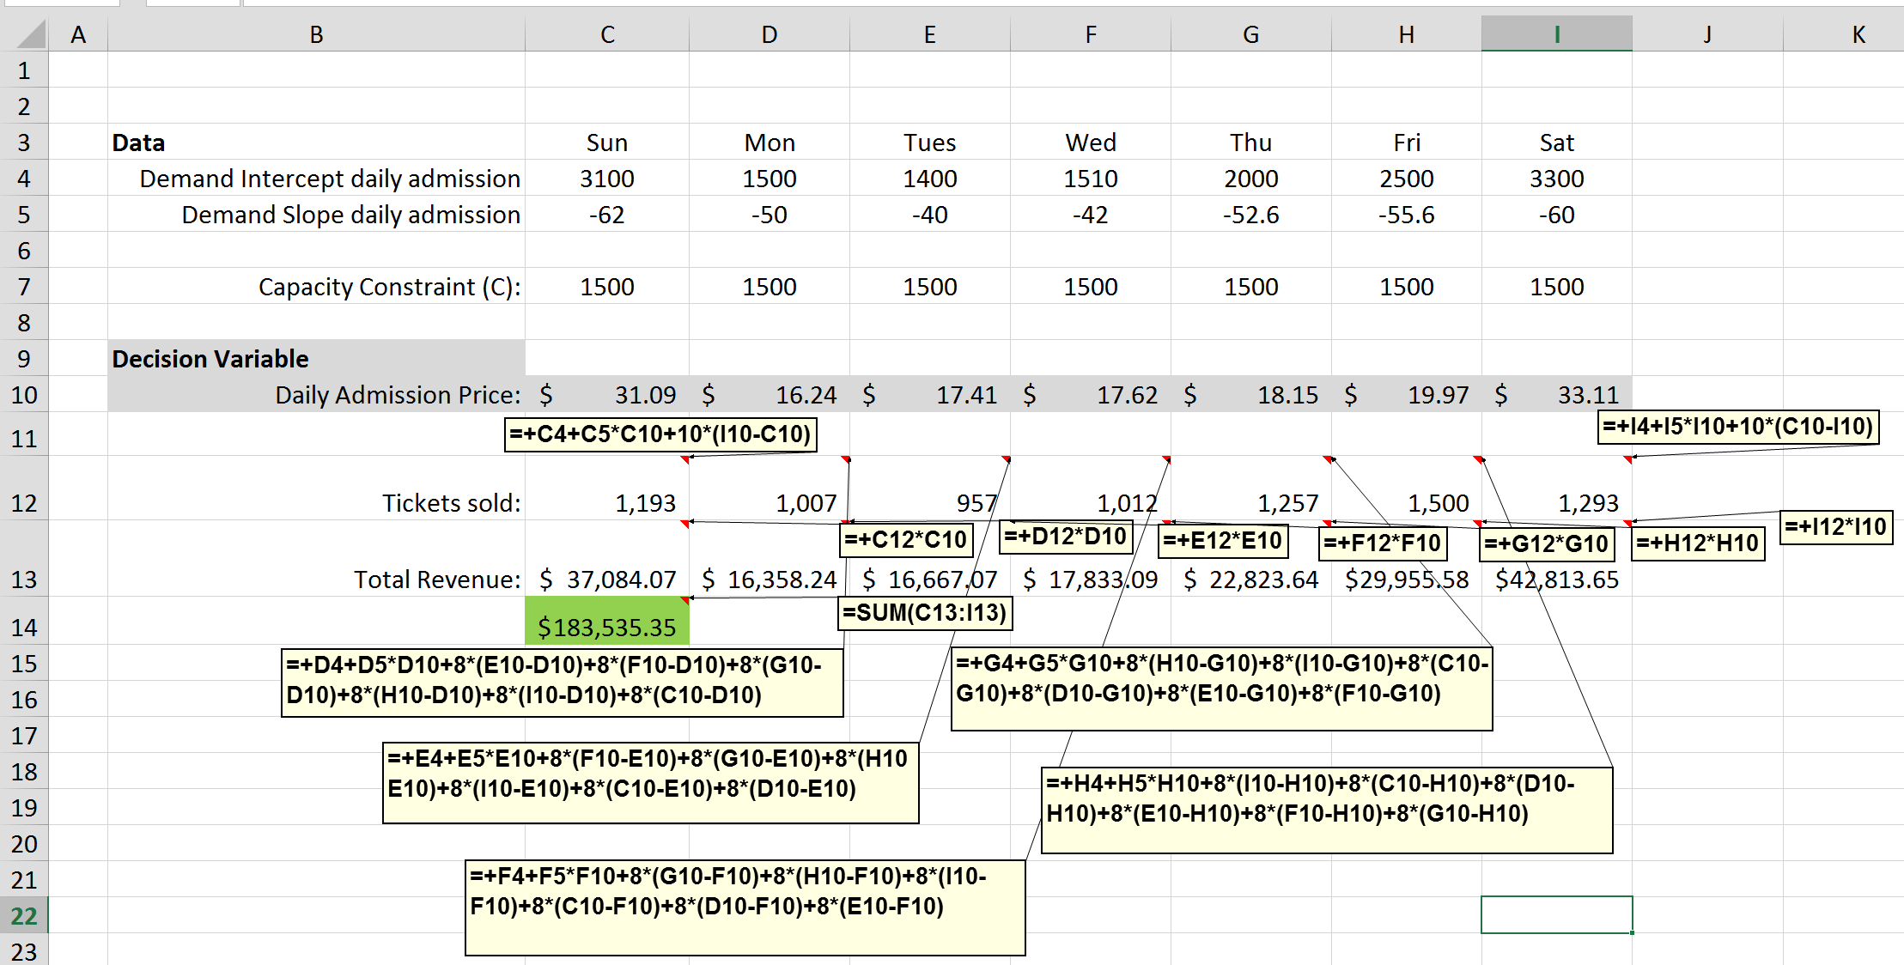



To determine the booking strategy, performed the following steps:

1. Demand - Assessed the demand of low fare (Restricted) tickets and high fare (Full) tickets using the provided 25 samples. Calculated and determined the demand mean and sd of both ticket classes as follows (please see rows (please see calculations in rows 51-56 in attached Data-Question-3 workbook):

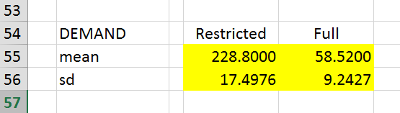 

1. No shows & cancellations - Calculated the probability of no show and cancellations as the percentage of no shows over restricted tickets purchased and cancellation over full price tickets purchased, respectively. Please see calculations in rows 58-62 in above attached Data-Question-3 workbook.
2. Allowed Overbookings – Made assumption of maximum overbooking that was allowed to be 10% of the given 300 capacity.
3. Simulation Model – Formulated an optimization simulation model using Oracle Crystal Ball. Please see the workbook which is organized by Data analyzed, Decisions, Calculations and Objective. Key forecasts used were:
   1. Low fare demand / high fare demand – using the CB.normal function with the calculated demand mean and sd
   2. # of No Shows and # of Cancellations – using the CB.binomial function with the calculated no show and cancellation probabilities (p) and number of reservations (n)

In summary, set a virtual capacity amount of 330, which was 10% more than the actual capacity, then set the virtual overbooking protection level as the decision variable. Using the forecasted demands and no shows/cancellations, calculated:

- # of low fare and high fare tickets sold

- # of no shows (low fare) and cancellations (high fare)

- # of low fare and high fare ticket holders who got BUMPED

Then using this information, set the Objective as the Net Revenue, which was defined as Total Sales – Refunds for Cancellations – Costs of all BUMPS. Set the Decision variable as the Virtual Protection level for high fare tickets.



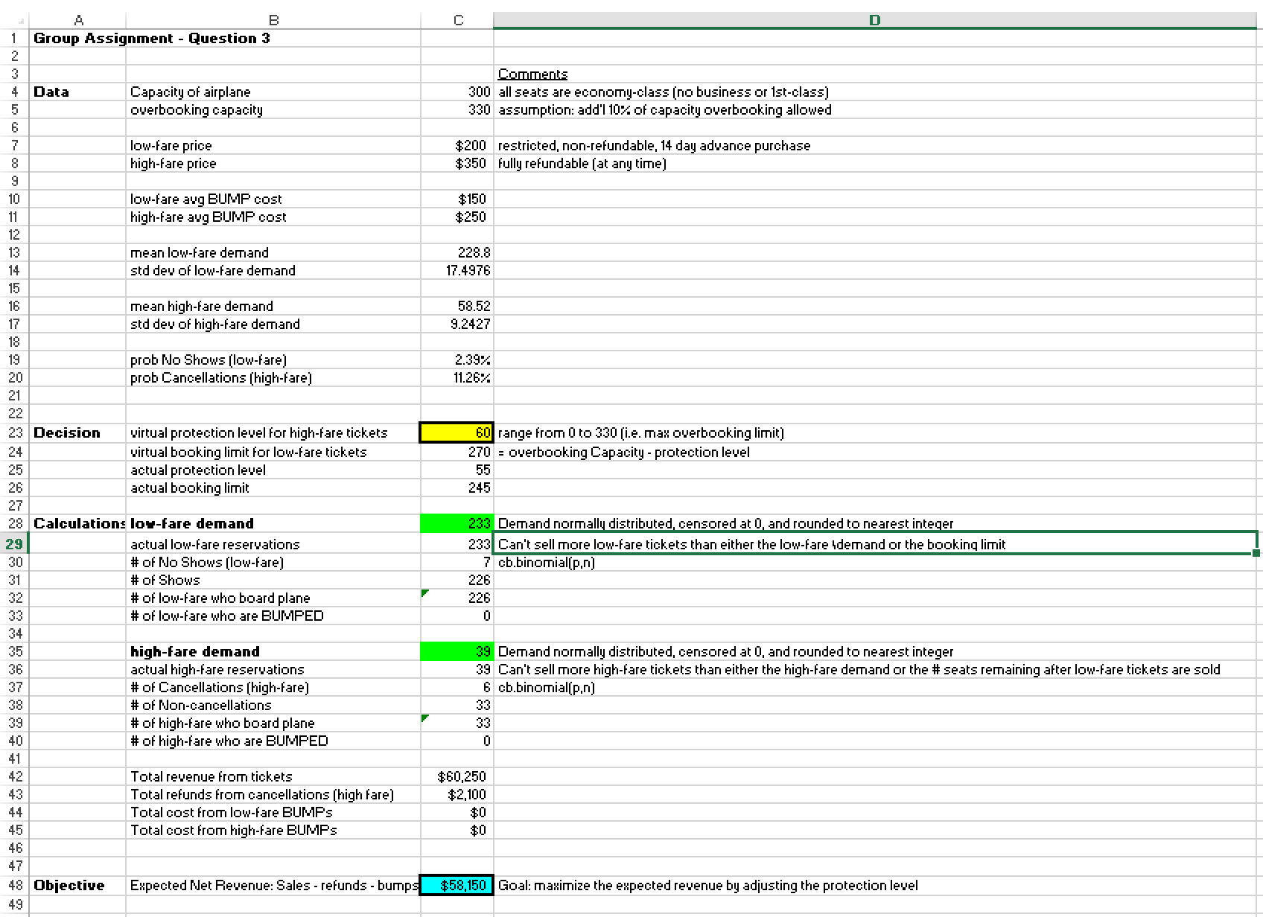

Used OptQuest to perform simulations for each possible decision variable with a lower limit of 1 and an upper limit of 329, with step size of 1. For each simulation, ran 10000 trials.

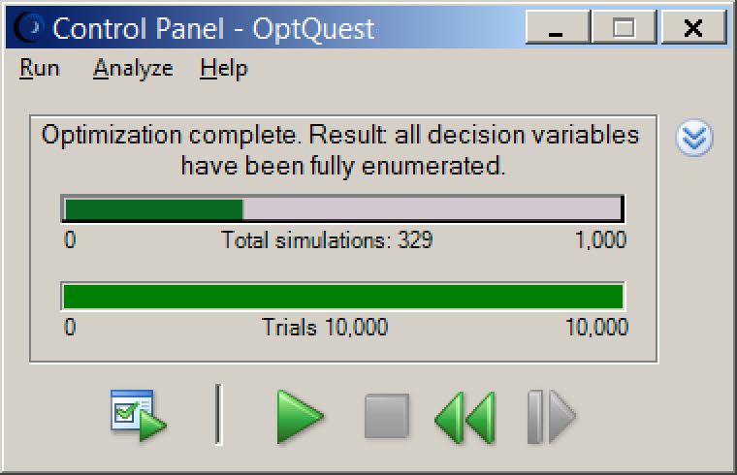

The results of the simulation indicated that the optimal overbooking protection limit for full fare tickets at a max overbooking capacity of 330, should be 69 and the optimal booking limit for low fare tickets would be 261.

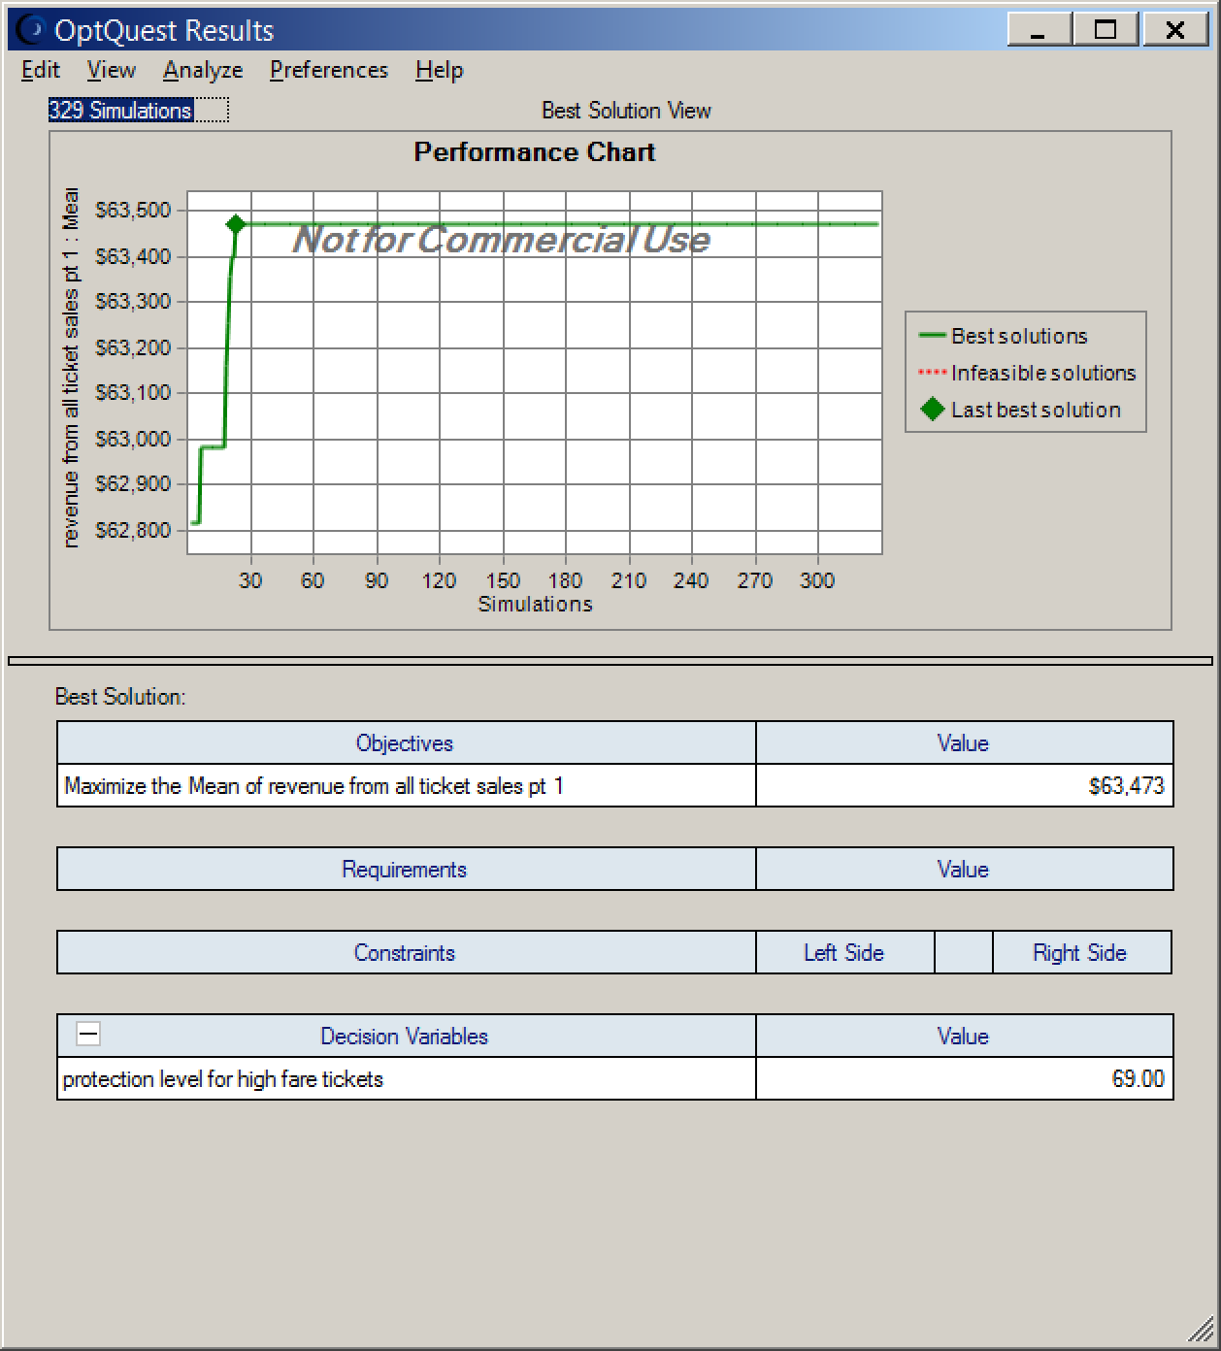

The average revenue is 63,473 as seen in the forecast output below. More specifically, the 95% confidence interval is the mean x critical value of 1.96 * mse, which gives us:

* 63,473 – 1.96 * 40 = 63,394.6
* 63,473 + 1.96 * 40 = 63,551.4

